Example
On the 22/10/2021 at approx. 3:30pm a staff member of the utilities team within the Wellington Water Alliance had finished works at a reservoir and was packing down for the day, he has tried to close the rear door but some tools were preventing the door closing properly.

The worker has then gone to tie his ladder down to his roof rack and while doing so he has been distracted by the door opening and then his team mate asking him a question, the worker has forgotten to check that his load is secure and left site. Approx. 20mins after setting off while in a 80km zone the worker has noticed the ladder come off his roof, he has pulled over into a safe area and returned to remove the ladder, a member of the public has pulled the ladder off the road and helped him return the ladder to his van. There has been no injury or damage and following a catch up with the worker it was discovered there was only one tie down used to secure the ladder

What you should know
- Ladders must have two tie downs, one at the top and one at the bottom
- Double check your load is secure before you set off
- Face hooks outward wen rigging a load (See picture below)

Timber props used after incident
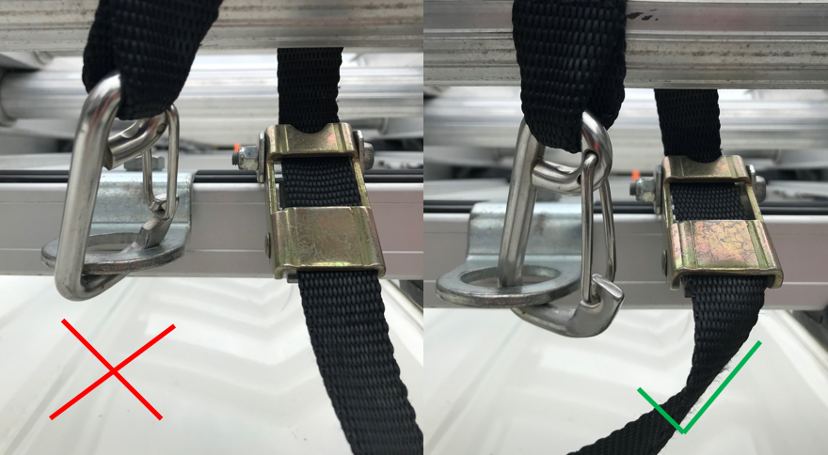

Date:
Name | Company | Signature

