TTM Safety Zone Breaches

What you should know?
On the 15th and 16th of August 2022, while responding to an emergency job on SH58 we have had two significant near miss events where members of COG have breached our subcontractors safety zones.

Both breaches were of a similar nature where members of COG have driven onto the footpath and berm on the left hand side of the Truck Mounted Attenuator (TMA), this while teams were actively working to complete TTM setups and in one of the instances the STMS was nearly struck by the vehicle.

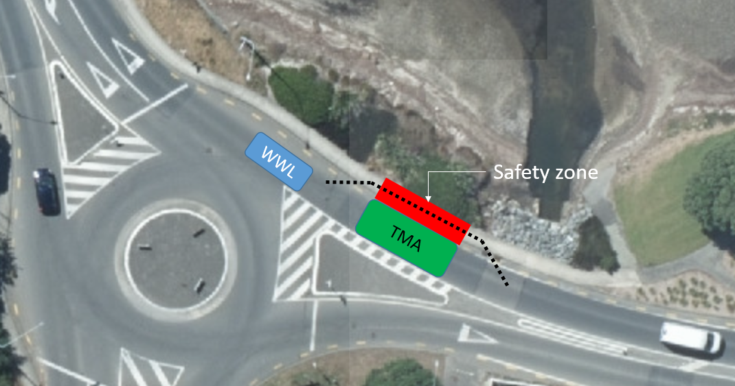

The left hand side of TMA’s are a safety zone for our TTM teams and should never be breached, our Life Saving Rule “We always keep ourselves and other away from machinery when we don’t need to be near it” applies to their safety zones.

Timber props used after incident

This is also a stark reminder of the incident that happened in May 2021 on a Fulton Hogan site where the same safety zone was breached by a member of the public in the Waikato, which resulted in a fatality and is still very much front of mind for our brothers and sisters working to keep us safe while we work on the road.
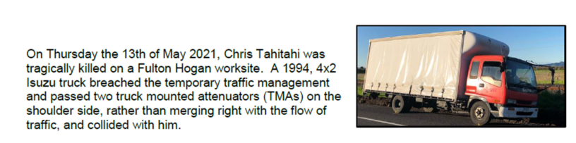
So if you need access into site don’t breach the safety zone, please pull over in a safe area and make contact with the STMS or TC crew to get safe access into site.
Normal road rules apply until the site has been established, until then you must only drive on the road. This helps protect our TTM teams and members of the public.
