Inspections Activities
Proposed scenario where a valve or manhole inspection in complete in the area below.
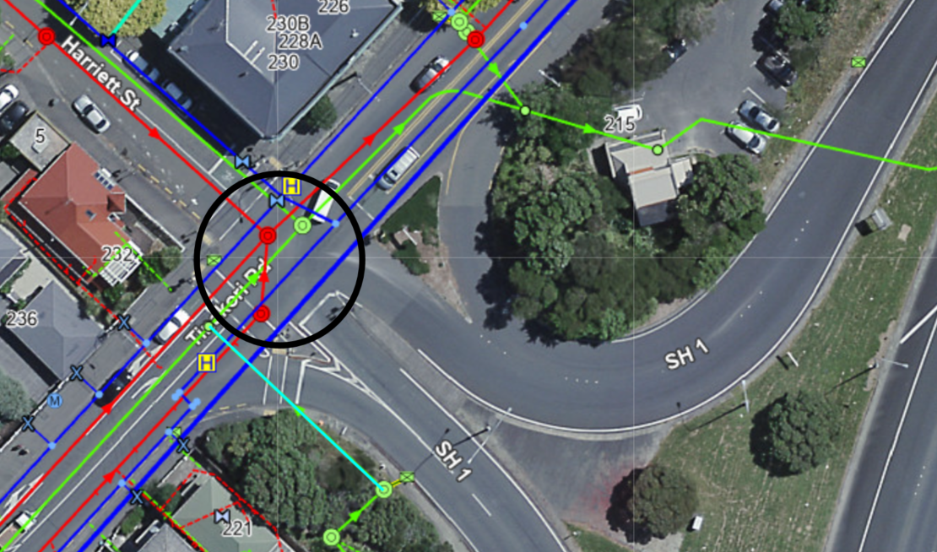

What you should know
- In this instance there was reference to an out of date inspection diagram and also reference to inspection activities within COPTTM – Although COPTTM allows for inspections the key in this instance is that inspections must be completed under an approved TMP and completed with compliance to COPTTM rules
- Life Saving Rule – We always have an effective plan to manage traffic, cyclists and pedestrians

COPTTM inspections:
- The general principle for Inspections and non-invasive activities is that the person undertaking the inspection must move to avoid traffic on the road, i.e. they must not expect traffic to move or slow down for the inspection activity
- If an inspection is longer than 5 minutes then the inspection is not permitted and a mobile, semi-static or static closure must be used
- Completion of an inspection is a minimum two person activity – Working under an approved TMP following an STMS briefing and completed with a spotter in place, with consideration given to clear site distance, traffic volume and the time taken to complete the activity
- Refer to COPTTM or TMP for controls needed to complete an inspection

The Why?
Timber props used after incident
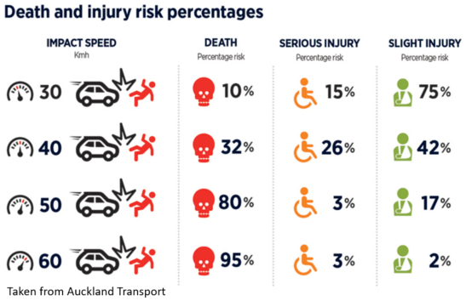
Other considerations:
- Hydrant inspections and flushing
- Pump station inspections
- Valve inspection, exercising and shut downs
- Manhole inspections
- Flushing blockages
- CCTV
- Leakage detection
- Mark outs
The above activities will fall into the same controls, the questions you need to ask yourself before completing any of the above are as follows:
- How long will it take?
- Will I need traffic to slow down or move around me?

If the answers are over 5minutes or yes then you cannot complete the works under an inspection activity and you must stop and speak to your Team Leader or Manager and get the correct controls in place.

Remember it is you who is at risk and is 80% likely to die if you are struck by a car doing 50kph
Look after yourself and your team mates.

Safety Alert Delivery | Inspection Activities
Date:
Name | Company | Signature

