Loss of Load from a Moving Truck

What you should know
on 27/07/2022 at approximately 11:00 AM a staff member of the Water team within the Wellington Water Alliance was returning to the Depot with a 6m lightweight pipe strapped length wise to the back of the track. While traveling the driver heard a noise and noticed in his left wing mirror that the pipe had swung sideways and was protruding down next to the vehicle. He pulled over and realised that, while the pipe was still strapped to the vehicle, the tie down configuration had not been sufficient to keep the pipe in place. A member of the public then informed him that their parked van had been struck with the pipe and had damaged the taillight and wing mirror. There were no physical injuries. Following a catch up with the worker it was discovered that he was not familiar with the rack feature of the new truck, and that the tie down configuration had not been sufficient to prevent the pipe from moving.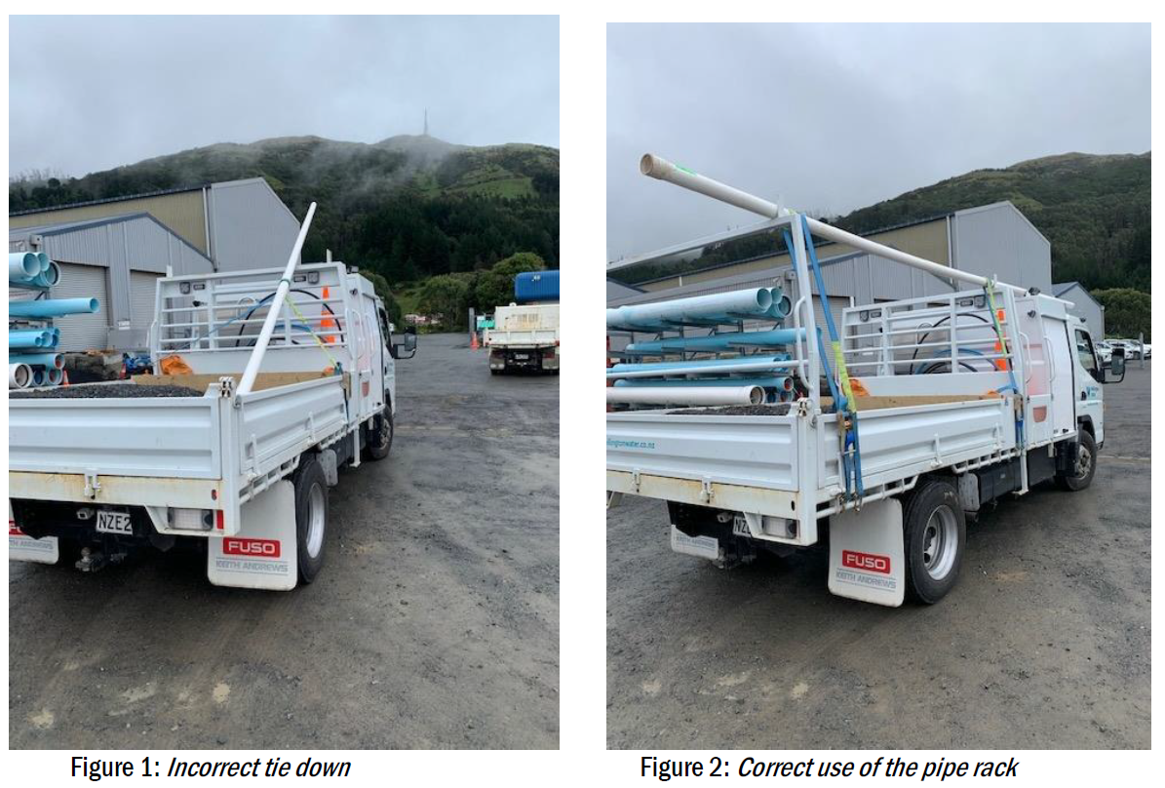
Expectations when carrying a load:
Timber props used after incident
- Check your load is secure before you move
  - Give the load a push and pull to check it’s secure
  - With longer items such as pipe, use two strops front and rear to increase load security
- Check your load after travelling 25km, and then regularly after that
- Whenever you add or move items
- After emergency braking or excessively sharp manoeuvre
- If you are unsure about how to secure a specific item then push pause and ask your Team Leader or Manager

Safety Alert Delivery | Loss of Load from a Moving Truck
Date:
Name | Company | Signature

