Eye Injuries
On 28/09/2022 a member of our team has noticed and irritation in their eye, the irritation has become progressively worse throughout the day and when returning to work the following day the irritation has been reported to their team leader.
The service person has then been taken to the doctors where they have been assessed as unfit to complete normal work duties and have then later been found to have pieces of dirt and metal in their eye.

What you should know
The service person could not recall a specific incident which led to the irritation, the potential causes were from the previous day were:

- Working around a hydrovac the previous day, although the service person was located approx. 2metres away from the work they were not wearing safety glasses
- Had used a grinder to cut bolts, but was wearing safety glasses during the task

What does out Living Safely Manual say about eye protection?
Timber props used after incident
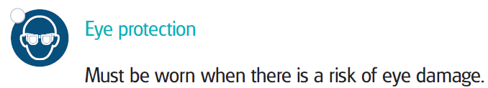
In your teams discuss the following points for 5 minutes and provide feedback to the group:
- What tasks do you undertake that pose the risk of eye injuries?
- What risks do our subcontractors introduce that pose a risk of eye injuries?
- How do we controls these risks?
- What task require secondary eye and face protection?

Examples of tasks we complete that pose the risk of eye injuries:
- Jet flushing
- Water blasting/hydrovac
- Use of pressurized air (Air vacs etc.)
- Use of concrete saws and grinders
- Use of breakers
- Working in windy conditions, where dust and debris can be blown into the eyes
- Use of hazardous chemicals
- Work around pressurised liquids
- Use of workshop tools and machinery
- Work around waste water where there is potential for splashes to the face
- Or anything that has the potential to cause injuries to the eyes
Secondary eye and face protection:
- When there is a risk of not only damage to the eyes but also the face
  - Examples - Concrete saw and grinder use
And remember to include the risks and controls in your Risk control Plan.
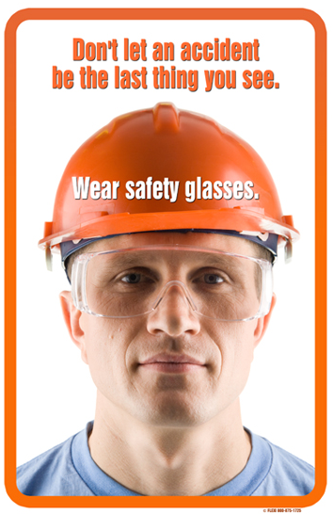

Safety Alert | Eye Injuries
Date:
Name | Date | Signature

