Electric Shock
A water service crew were attending a job in Miramar and while replacing a leaking fitting on PE (Plastic pipe) from the main to the manifold, the service workers has received a minor electric shock.
The electric shock has happened when the worker is touching the PE and copper pipes and has been un-doing the connection.

What you should know
- Electric shocks require to be notified to WorkSafe NZ and checked by a medical professional to ensure that there has been no damaged cause such as a change in the hearts rythym
- The job has been revisited with a Wellington Water electrician and Wellington Electricity stand overs, this has discovered the fault has not come from an earthing issue from the house but a general leak in the area which WE is investigating further
- Actions and controls have been developed in consultation with a specialist in this area
- A set of controls has been developed, including the use of earthing/bonding and PPE that will be implemented ASAP
- In the interim all metallic pipes are to be bonded using jumper leads with a rating of not less than 75 Amps and when bonding is not achievable then earthing must take place with a minimum of 150mm deep earth stake and jumper leads with a rating of not less than 75 Amps
- The above should take place prior to any works on a metallic pipe including ones connected to PE pipes
- Do not rely on volt sticks as – Electrical appliances such as refrigerators and washing machines cycle on and off, this means the fault may not be detected either side of the work area until the appliance starts again
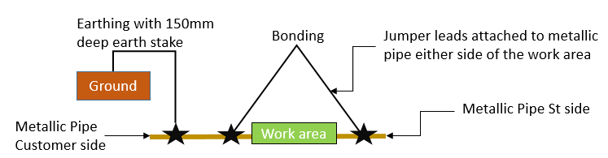
Timber props used after incident

