Driveway void leads to gas main damage
Retic team received a call out to a burst water main in Whitley Ave in Upper Hutt, when the team arrived on site they were greeted by a third party contractor this contractor has been grundomatting under a driveway and during doing so they have damaged the water main causing a burst. The crew has completing their risk assessment and digging permit, when looking for underground services they have referenced mark outs completed by the third party contractor that show a gas line in the footpath but not in the drive where the leak was, approx. 1.5m away. The team has then completed concrete cutting to the driveway to expose and repair the leak, when the last cut was made the section of concrete has fallen into a void below hitting a gas line and damaging it. The void has been created by the burst water main undermining the driveway and the team were unaware of this until making a cut to remove concrete.
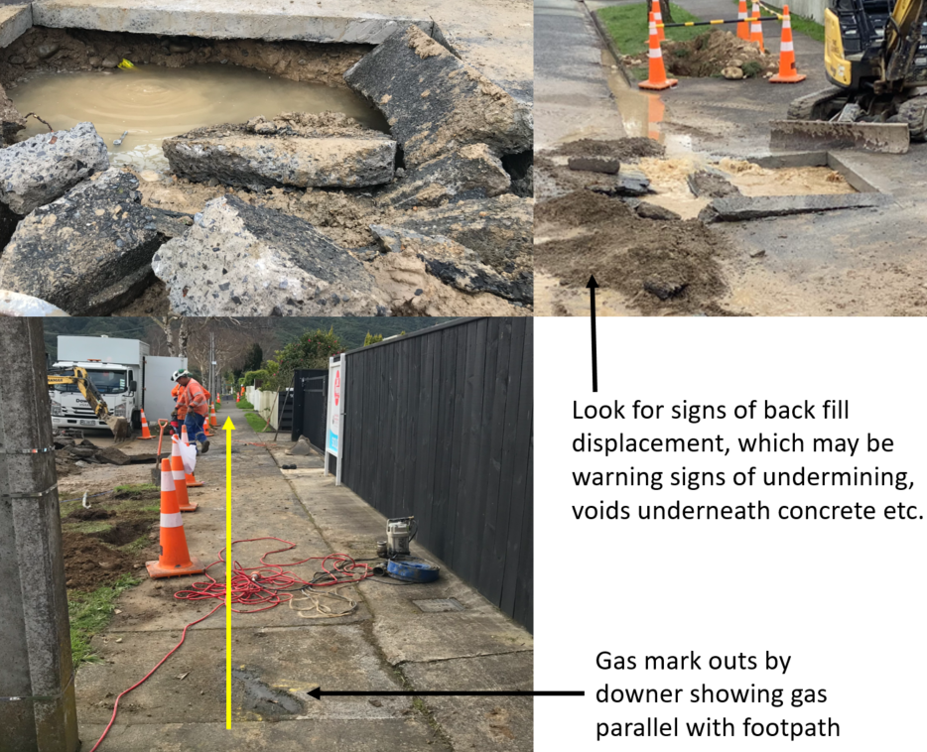

What to look for to & do prevent this re-occurring?
- Look for signs of displaced materials in the area
- Check ground conditions for sagging of asphalt, grass around concrete edges etc.
- Remove a smaller section of concrete first to check for voids and undermining
- If a void or undermining is found then remove smaller sections to prevent damage to any potential services in the area below

Timber props used after incident

Safety Alert Delivery
Date:
Name | Company | Signature

