Sewer lateral repairs
On 18.05.2021 a worker was tending to a blocked sewer lateral when he has received a cut resulting in 8 stiches to his wrist.
When completing works a cut was attempted with a battery grinder, the grinder has stopped working due to a fault and as the trench width did not allow for a concrete saw to complete the cut, the serviceman had chosen to break and remove the earthenware pipe to then remove the blockage. It is at this point when the serviceman has caught his wrist on the earthenware pipe causing the cut which has led to 8 stiches.
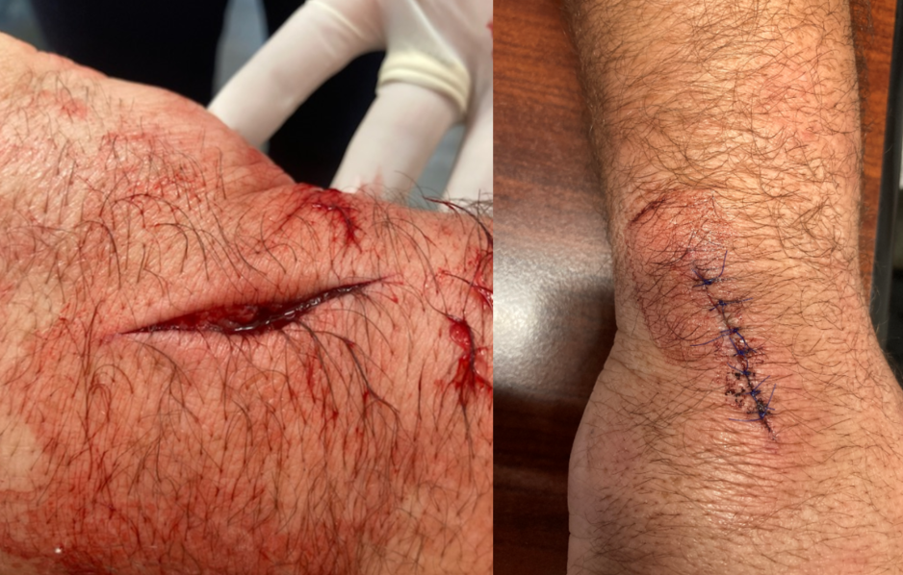
Potential outcomes and complications:
- Tendon – love of function/movement
- Nerve – Potentially life long localised pain
- Bugs and disease from waste water
- Loss of feeling or sensation
- Infection

Expected process for lateral repairs
- Complete RCP
- Site walk over/team toolbox
- Make sure everyone on site is fully aware of the risks and controls to do with the task, including consideration to correct work methods and appropriate use of tools and PPE
- Mark out the proposed trench
- Locate all underground services, including potholing with non-conductive hand tools to ascertain heights and directions
- Pre-start checks on excavator, all excavators are to have current FH safe cert or plant induction and operators are to have relevant training and CTO for excavator use
- Excavate and expose the sewer pipe making sure trench is wide enough to fit a concrete saw if needed.
- Check sewer boundary kit to see if the sewer pipe is flowing or if it is blocked. If property does not have a boundary kit, then check the nearest gully trap outside of the property.
- If the pipe is blocked, the lateral will need to be flushed to unblock the pipe before any repairs are attempted
- Once pipe is unblocked, mark out the area on the pipe to be replaced
- Before any cutting is made prestart checks are to be done of tools, operators must have CTO for concrete saws and/or grinder use, correct PPE must be worn, then proceed to make the cut
- Measure out the length of pipe needed
- Complete repairs wearing correct gloves for the job
- Slide vernco fittings over the cut piece of pipe and position pipe into place then tighten vernco fittings to existing sewer pipe

Key take away:
Timber props used after incident
- If you have a control within your RCP then make sure you use it
- Consider if your current work methods can be done safer? Always look to continuously improve
- Always use the PPE required for the job – this is your last line of defence and you should always consider is there another way to do the job
- If something changes (Grinder can’t make the cut) push pause and ask yourself the stay safe questions
