Comms cable cut inside pipe
A retic crew hand excavated to complete repairs on a leaking water pipe
Once exposed they have found 3 black pipes that all resembled water pipes
One of the crew members has attempted to trace the pipe he was cutting back to the water supply
Once the pipe was cut the crew discovered that there was a Comms cable within the pipe
The crew has found although this pipe was in the same vicinity and appeared to be heading in the Same direction as the water supply that it was not in fact the same pipe
and was heading in another direction under dirt excavated after the fact

What you should know
- Refer to plans and use a Cat scanner on unknown pipes
- Never make assumptions of what you think may be within pipes
- Complete a risk assessment and look for tell-tale signs of services in the area
- Turn water on/off and check/listen for water flow to help confirm that the pipe is water
- If you cannot confirm the contents of a pipe and there is multiple pipes, expose them fully to ensure you know where they lead before making cuts
- Consider pipe sizes and compare to usual water pipe sizes

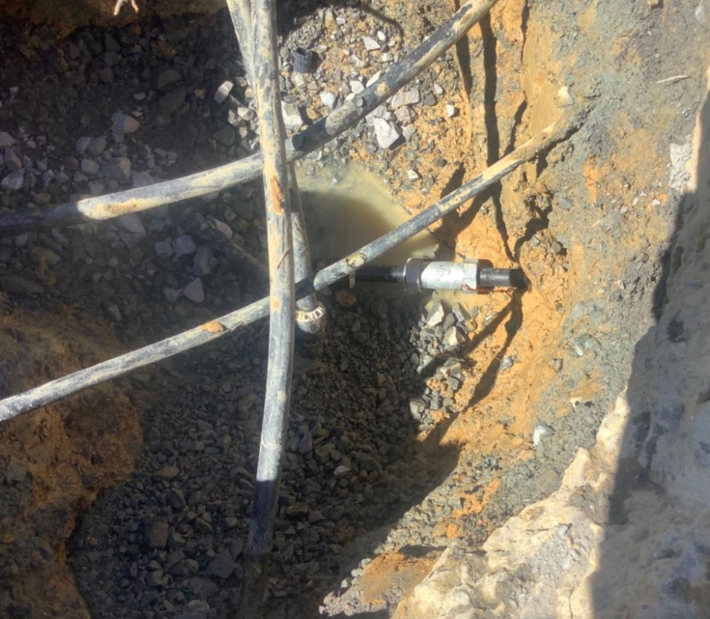
Timber props used after incident

