Section 1: Required whenever we are digging, penetrating, raking, milling, or otherwise disturbing the soil deeper than 150mm including installing posts, guardrail, kerb pegs, waratah standards etc. Exemptions: Refer to the COG Living Safely Manual and record clearly on the Risk Control Plan.

Can this task be completed without excavation? |  | Yes / No | Job # |  |  | Date:
Valid from: (date & time)  Max duration 7 days |  |  |  |  | To: (date & time)
Team Leader: |  |  |  |  | Service Worker:
WorkSafe Notification: Do any of the following apply? Work is being done in:
- a drive, excavation, or heading and someone is required to work with a ground cover overhead
- an excavation in which any face has a vertical height of more than 5 metres and an average slope steeper than a ratio of 1 horizontal to 2 vertical
- a pit, shaft, trench, or other excavation more than 1.5 metres deep and having a depth greater than the horizontal width at the top
No Continue with permit | Yes WorkSafe NZ notification required 24 hours before work starts |  |  | WorkSafe Notification date & reference number:

Plan & Do: If the answer to any question is in a grey box, then work cannot proceed until the relevant item has been completed or risk assessed and controls included in your RCP e.g. mark outs, hand digging
Item | Check |  |  |  |  | Yes | No | N/A
 | Has a physical site inspection been completed?
 | Have you checked for indicators of services and other hazards? Check for gas meters, comms towers etc.
 | Do we have plans for all known underground services for the site? e.g., B4UDIG
 | If no to above, have service providers confirmed “No services in area”? Or a mark out completed? (no response does NOT confirm no services)
 | What method of cable location are we using? E.g., Cat & Genny, contractor
 | Is potholing required? (Potholing is required when using an excavator)
 | If potholing is required, what is the determined frequency and location of potholing?
 | How are we potholing? |  | Hydro or air excavation
 |  |  | Hand digging with non-conductive tools
 | All required close approach permits have been organised and any required controls by the utility owner are in place? (Refer to Service Distances Poster)
 | Overhead | Distance / Comments |  | Underground | Distance / Comments
 | Electricity: |  |  | Electricity:
 | Rail: |  |  | Fibre:
 | Other: |  |  | Gas:
 | Other: |  |  | Water or other:
Item | Check |  |  |  |  | Yes | No | N/A
 | What other special requirements are there?
 | Utility Rep stand over?
 | Designated trained spotter?
 | Residents notified?
 | Client Rep notified?
 | Have we identified what edge protection and / or shoring is required?
 | Has a communication method been agreed between the excavator operator and stand over/spotter and what is it?
 | Is there means to protect services when/if found? e.g., plywood
 | An effective plan to manage traffic, cyclists & pedestrians is in place?
 | Are environmental controls in place? E.g., silt socks and witch hats
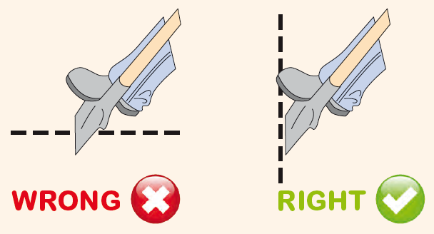
IF AN EXCAVATION BECOMES 1.5M OR DEEPER STOP WORK CONTACT YOUR TEAM LEADER TO COMPLETE DIG PERMIT FOR DEEPER THAN 1.5M
CHECK:
16. | Self-issue:  I confirm that everyone involved in the task understands the controls and communication requirements. I believe it is now safe for work to start.  Signed: Date:  Name: Position:

ACT: If any of the following hold points occur STOP and ask yourself the Stay Safe questions.
If all known (and indicated) services in the dig area have not been positively located work cannot proceed, contact your team leader.
If you encounter a previously unidentified service, work must stop, contact the Team Leader and Service Provider put a plan in place to manage the risk.
If something changes, work must stop, contact your Team Leader, hazards and risks must be reassessed before work can proceed.
If the person who completed the permit, excavator operator or spotter changes at any stage, work must stop, and the permit must be reviewed by the new operatives. This change must be documented on the risk control plan
