Our Customer Promise
As a customer-centric business we intend to build on and improve the social licence we have to operate through a wider acceptance and understanding of what we do and why we do it. This relies on our Customers having a clear understanding of what they can expect from us and of the Levels of Service we deliver.
Through this process and by operating according to our values, our commitment is that Customers will increasingly value the services they receive and are well informed, thereby building trust in Wellington Water through their engagement with us.
Attachment 2
Our Organisational Communications Strategy will support this promise through making sure we:
- Build community understanding and knowledge of infrastructure investment, the benefits of the investment and challenges,
- Contribute to changes in behaviour to improve water quality and conservation; and
- Make it easy for the public to know what is happening to their water services.

Agreed Levels of Service
Our most critical assets are the pipes, pump stations, reservoirs and treatment plants that we simply can’t afford to lose – the heart, kidneys and major arteries of the network. If they failed, there would be a major, unacceptable impact on our Customers, the community and the environment.
This category includes about 6,800 kilometres of pipes, 388 pump stations, 147 reservoirs, seven water and eight wastewater treatment plants across the region.
Logically, this means that these critical assets receive our highest priority to fix and maintain. We would stop everything we’re doing to solve a problem with these assets should it occur and give ourselves eight hours to do it. To make sure we are using our resources efficiently and effectively, we assign non-urgent issues more time to resolve of twenty business days, so our maintenance teams can plan work schedules. Our Service Standards to resolve network issues are as follows:
Priority Rating | Time to advise Customers | Time to restore service | Time to advise outcome
Significant Incidents and outages | Within 30 minutes via Phone, SMS messaging*, all Social Media platforms (Twitter, Neighbourly, Facebook, Instagram), WW Website and media if required | 8 hours | 1 business day  Note: Status updates will be made via all channels every two hours until resolution.
Urgent faults | 1 hour via Phone, Twitter, SMS messaging* | 8 hours | 1 business day
Non-urgent faults | 1 hour via SMS messaging | 20 business days | 25 business days
Planned works | Work programme – BAU channels | As programmed | As programmed
*Wellington Water offers a subscribe-by-text service that will push notifications about faults and possible service disruptions to people, based on their geographical areas of interest.
A guide to help you understand priorities
To help you share the same understanding of what constitutes an incident, an urgent fault and what a non-urgent fault is, we have crafted a quick guide:
An incident is defined as an outage where significant number of customers are without service, severe environmental damage is likely or the impact of the outage on the economy of the city is threatened. | An urgent fault is where service is interrupted or there is an imminent health, environmental and/or safety risk that requires us to deal with these quickly. | A non-urgent fault does not have the same immediacy for action so can we batch jobs and complete them as our crews become available. The timing of completing these non-urgent works varies depending on the level of incidents and urgent work being managed.
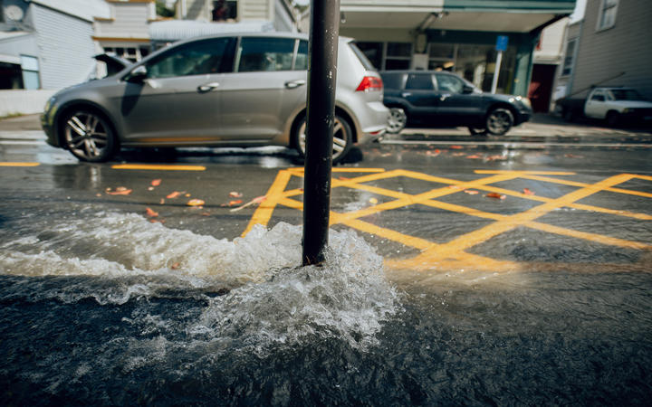 | 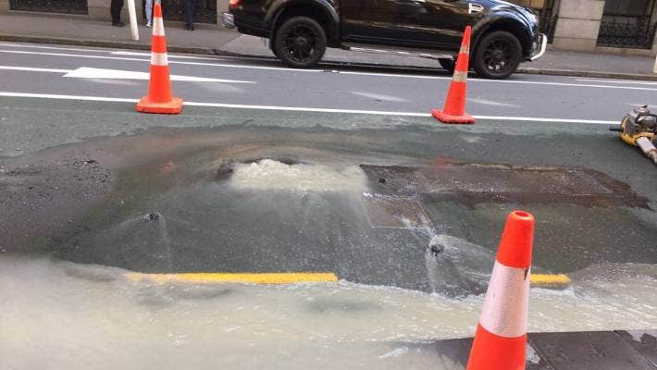 | 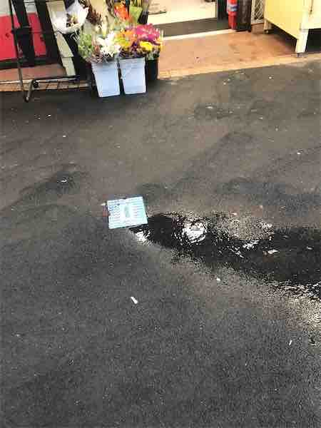

Your Customer Experience
We care about what your customer experience with us is like. Major incidents and outages through their nature necessitate significant care to minimise the impact of the disruption to our Customers and Community. To support this, we promise to let our people know what’s happening, what is expected of them and when things will back to normal.
We want to know that everybody is being looked after, especially our vulnerable customers. At the same time we will advise the community and public about what’s happening, we will collect information about who has been affected, what their service needs are so we check on them during and after the response.

Responding to you

If you ask us a question about how things work or a general enquiry, we will get back to you in 1 working day.
If you have a complaint, we will get back to you the same day with an update about what to expect.
When you report an issue, we will let you know the priority that’s been given to it and what that means regarding our response within a hour.
We will let you know how you can check on the progress of your question or complaint, and what channels you can use to access the information.
If you’re unhappy with the service you receive, we will ensure that you know about your options - OIAs, Utilities Disputes.

Our relationship with you
We all have a part to play in caring for our 3-waters infrastructure, so here is what you can expect from us and what we expect from our Customers and Community.
Service | We will: | You will:
Customer Care | - Do our best to understand your needs and, where possible, deliver services to meet your needs  - Be professional, open, and act with integrity while treating you fairly, consistently, and with respect  - Provide you with the information and support you need during works and/or incidents that affect you. | - Help us to keep our staff and yourself safe while works are being carried out  - Be open and honest when dealing with us  - Respecting our role on the network and the work we do, even if you don’t agree with some of the decisions.
Wastewater | - Maintain and enhance the network  - Prevent overflow discharges to the environment | - Only putting the three P’s down the toilet  - Report anything that seems wrong in the network or people mistreating the network
Water | - Deliver clean, clear, and healthy drinking water  - Repair leaks in a timely, efficient and effective manner  - Renew and enhance drinking water storage | - Use only the water that you need to  - Observe watering restrictions in summer months  - Are prepared for unscheduled interruptions to service (at least 8 hours with no water delivery)
Stormwater | - A commitment to best practice for managing the wider catchment  - Plan for climate change | - Avoid blocking the natural flow of water overland  - Make sure that your stormwater isn’t being directed into the wastewater system (contributing to overflows)

