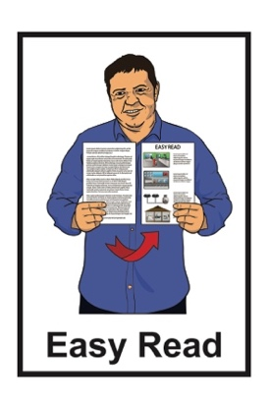

How to save water at home
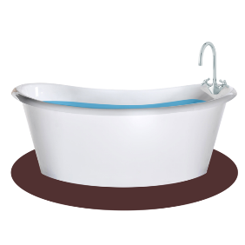
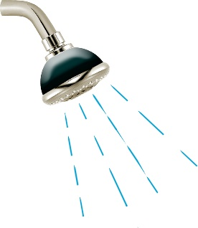
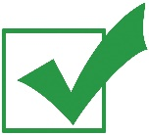

Published: April 2024

Why you should save water at home

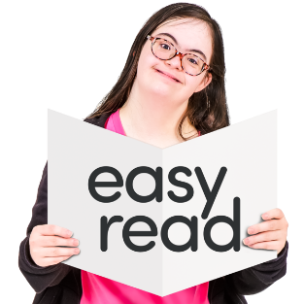
This Easy Read document is about how you can save water at home.

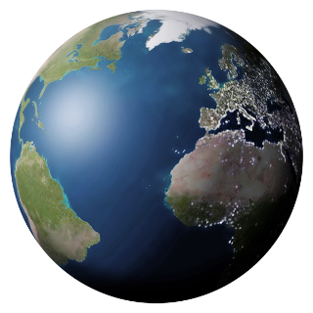
Saving water is good for:
- taking care of the environment
- following water restrictions.

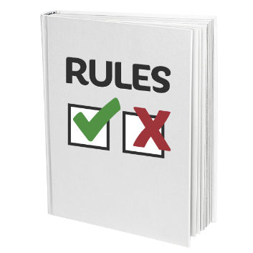
Water restrictions are rules that local councils sometimes have about how much water you can use.
These are to make sure the water does not run out.

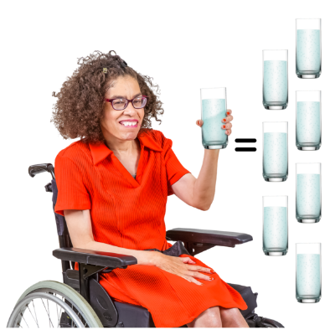
Even if you are trying to save water it is important to still drink enough water to stay well.

Do not drink less water to try and save water.

Tips for saving water

There are lots of good ways to save water.

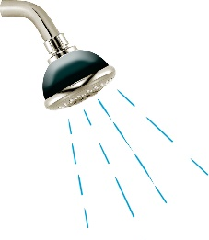
In the bathroom you can:
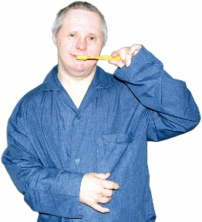
- take short showers that are no longer than 4 minutes
- turn off the tap while you brush your teeth
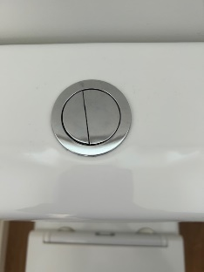
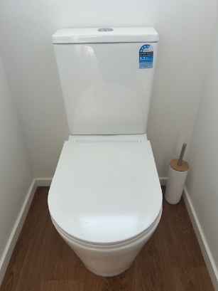
- if your toilet has 2 buttons use the half-flush button.

A half-flush button makes the toilet use less water to flush.

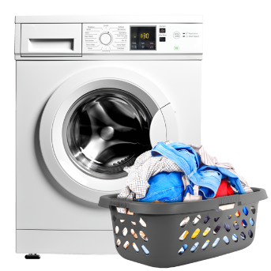
You can save water by only running the washing machine when it is full of washing.

In the kitchen you can:
- do the dishes by hand instead of using your dishwasher
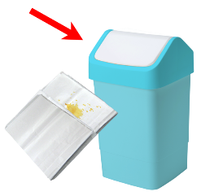
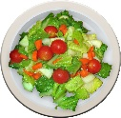
- scrape food scraps off plates into the bin instead of rinsing the plates before washing them.
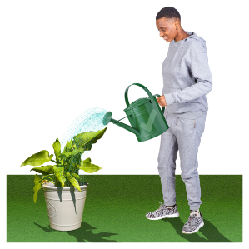

You can water your garden in the:
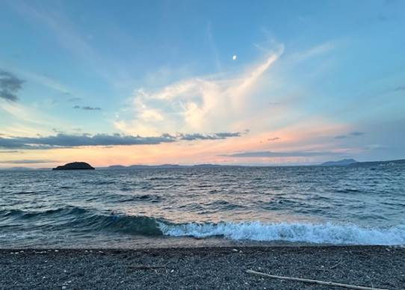
- early morning before the sun is fully up
- early evening when the sun is setting.

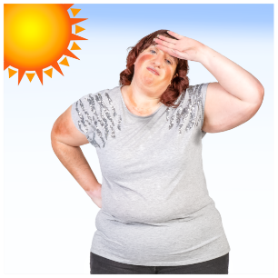
Watering your garden at these times means that the water will not dry up as quickly as when the sun is up.

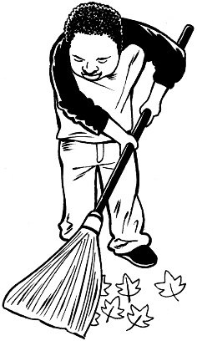
When cleaning up outside you can use a broom to brush things away instead of using the hose.

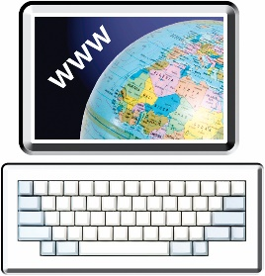
For more ideas on how to save water at home:
- go to our website at:
www.wellingtonwater.co.nz
and
search for:
Water saving tips

Contact us
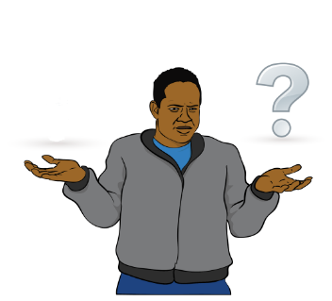

If you have any questions you can contact us by:
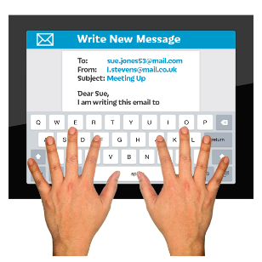
- email at:

customer@wellingtonwater.co.nz
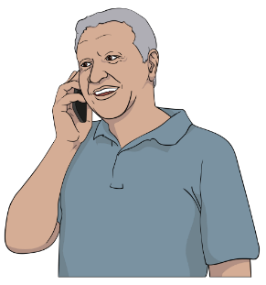
- phone on:

04 912 4400

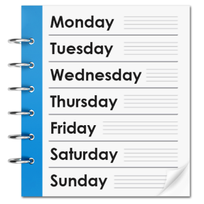
You can call us:
- Monday to Friday
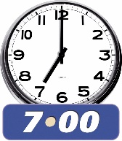
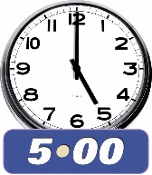
- between 7:00 am and 5:00 pm.
If you find it hard to use the phone the New Zealand Relay service is for people who are:
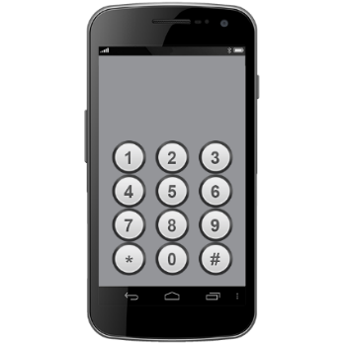
- Deaf / hard of hearing
- deafblind
- speech impaired / find it hard to talk.

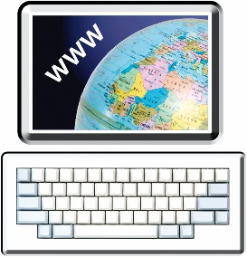
You can find out more about the New Zealand Relay service at:

www.nzrelay.co.nz

This information has been written by Wellington Water.

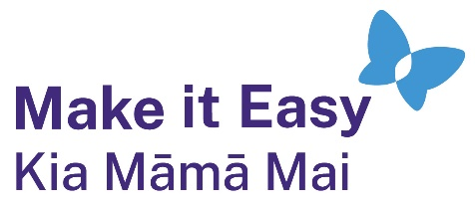
It has been translated into Easy Read by the Make it Easy Kia Māmā Mai service of People First New Zealand Ngā Tāngata Tuatahi.
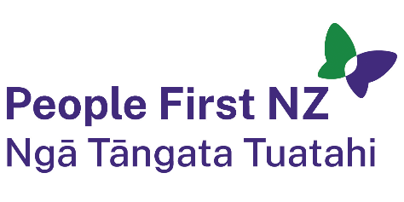
The ideas in this document are not the ideas of People First New Zealand Ngā Tāngata Tuatahi.
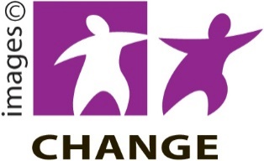
Make it Easy uses images from:

- Changepeople.org

            - Photosymbols.com

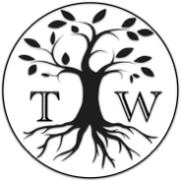
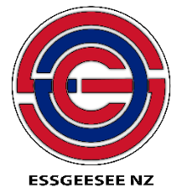
- SGC Image Works

- Huriana Kopeke-Te Aho

- T. Wood.
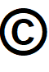
All images used in this Easy Read document are subject to copyright rules and cannot be used without permission.

