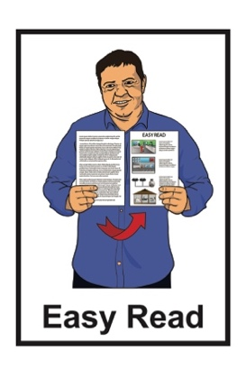

What water restriction levels mean for you
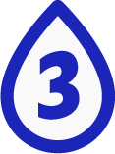

Published: April 2024

About this document

This Easy Read document is about what you need to do when there are water restrictions where you live.

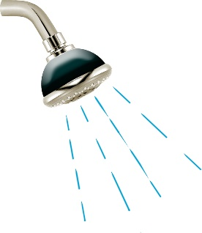
Water restrictions are rules that local councils sometimes have about how much water you can use.
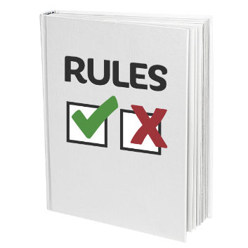
These are to make sure the water does not run out.

Why do we have water restrictions?
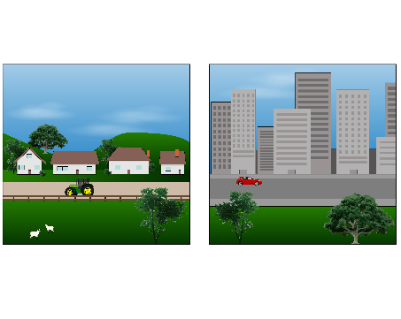

Each area has a daily limit on how much water they can use each day.

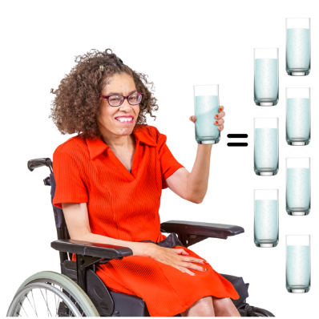
A daily limit means the most water that can be used in 1 day by all the people in 1 area.

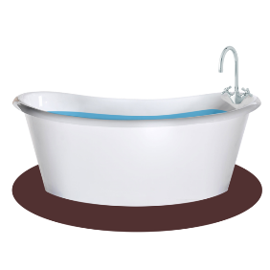
This means that we need to be careful to not use too much water.

Sometimes we need to use even less water when the weather is:
hot
dry.

When an area needs to use less water than usual their local council might use water restrictions.

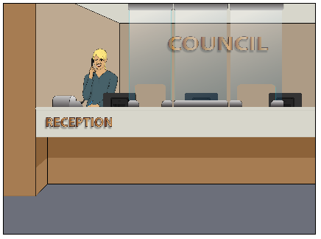
A local council:
makes choices about things in a local area
runs some of the services in that area.

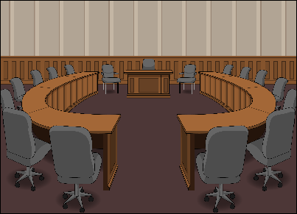
In the Wellington area these councils are:
Wellington City Council
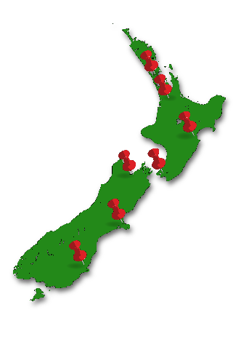
Porirua City Council
Hutt City Council
Upper Hutt City Council
South Wairarapa District Council.
Using water restrictions means that there will be enough water to make sure everyone has what they need.

You need to always have water for:
drinking
washing
cleaning.

Water restriction levels

Water restrictions have 4 sets of rules called levels.

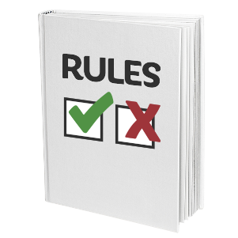
Each level has different rules to follow until the council changes the water restriction level.

Please do not drink less water than you normally do to try and save water.

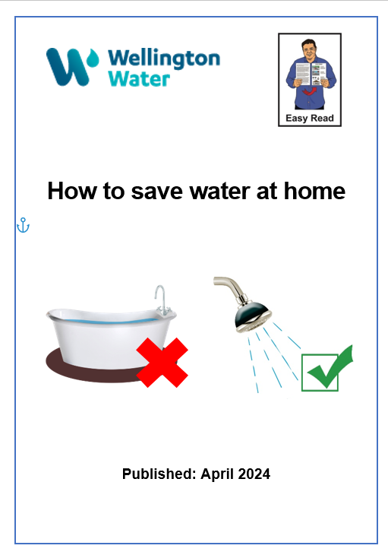
You can find good ways to save water in the Easy Read document:

How to save water at home

You can find this document on our website at:

www.wellingtonwater.co.nz

Water restriction level 1

At level 1 you can use:
your sprinklers every second day
your irrigation system every second day
any handheld ways of watering at any time as long as you do not leave them alone.

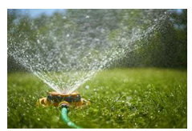
An irrigation system is something that waters a garden without a person there.

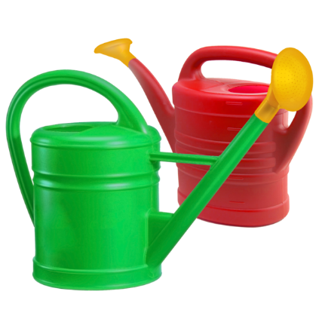
Handheld means things you hold in your hand to water like:
a watering can
a hose.

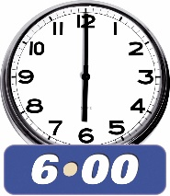
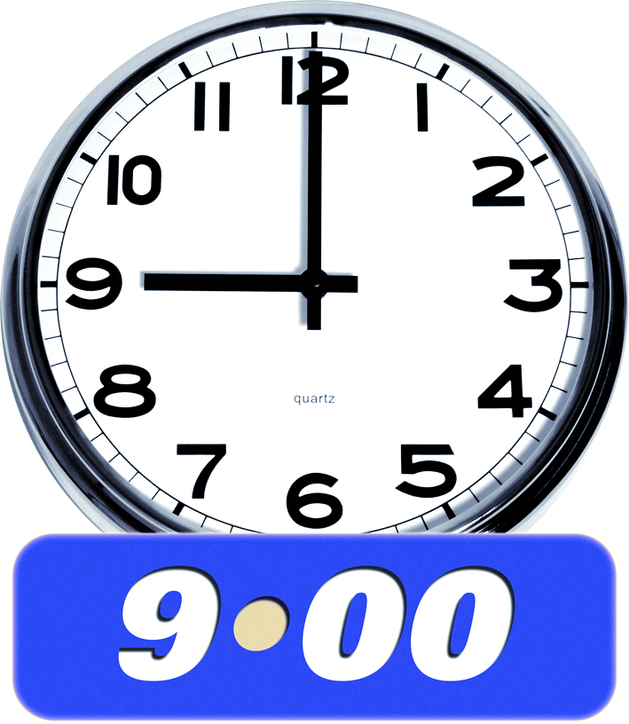
You can use things like sprinklers between:
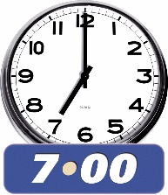
6:00 am and 8:00 am
7:00 pm and 9:00 pm.

Using things like sprinklers at these times means that the water does not dry up quickly in the sun.

5
The way we choose who gets to use their sprinklers is based on house numbers.

Sorting houses by their numbers changes how much water is being used each day.

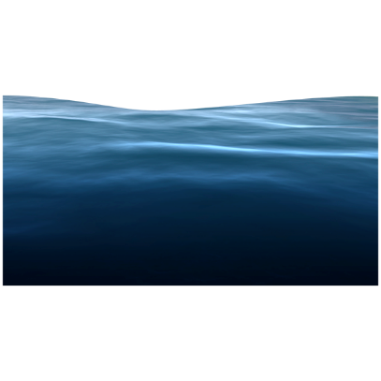
This helps us make sure we have enough water.

Even numbered houses can use sprinklers on even numbered days.

Even numbered means numbers that end in:
2
0
2
4
6
8.
26

This means that someone who lives in a house number like 26:
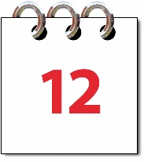
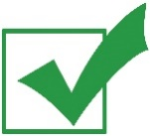
can use sprinklers on an even day like April 12
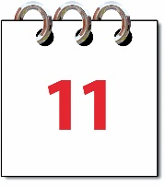
cannot use sprinklers on an odd day like April 11.
Odd numbered houses can use sprinklers on odd numbered days.

Odd numbered means the numbers that end in:
1
1
3
5
7
23
9.

This means that someone who lives in a house number like 23:
can use sprinklers on an odd day like April 11
cannot use sprinklers on an even day like April 12.

Water restriction level 2

At level 2 you cannot use any ways of watering that you leave alone like:
sprinklers
irrigation systems.
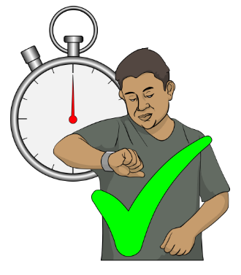

You can water your garden by hand:
at any time
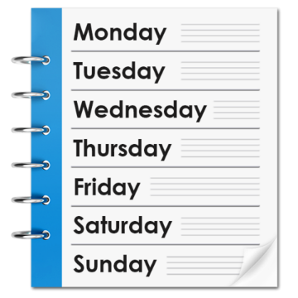
on any day
if you do not leave what you are using for watering alone.

Water restriction level 3

At level 3 nearly all people are not allowed to use any water if it is outside their home.

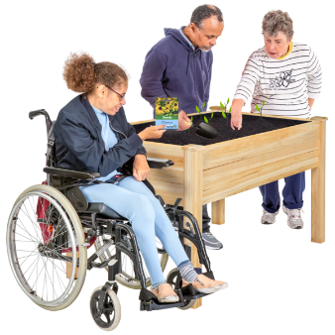
You can water your vegetable garden if you are growing food to eat.

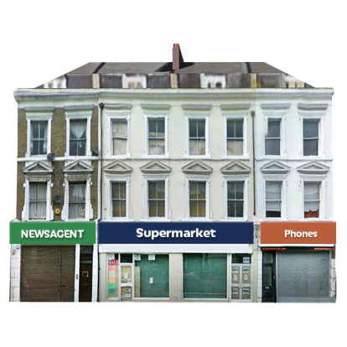
Businesses can still use water outside if they use the water carefully.

Following the level 3 rules can make the chance of moving to level 4 less likely.

Water restriction level 4

Level 4 means that there is not enough water.

At level 4 nearly all people are not allowed to use any water outside.

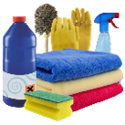
This means you cannot do things like wash your car.

You can water your vegetable garden if you are growing food to eat.

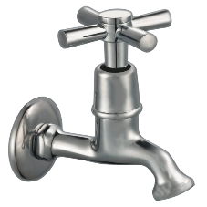
At level 4 we need to use only a little water inside so that there is enough water for everyone.
To help save water you should:
stop using any water outside
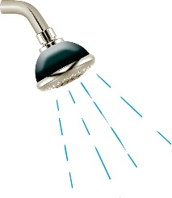
only take 2 minute showers.
2 Min

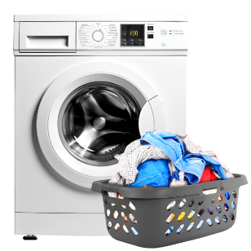
You should only do 1 load of washing for each person in your house each week.

This means that if your house has 3 people you only do 3 loads of washing each week.

Contact us
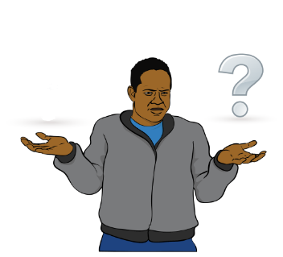

If you have any questions you can contact us by:
- email at:

customer@wellingtonwater.co.nz
- phone on:

04 912 4400

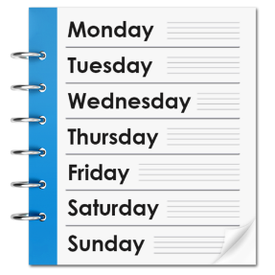
You can call us:
- Monday to Friday
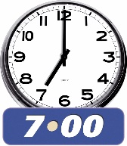
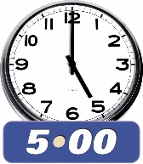
- between 7:00 am and 5:00 pm.
If you find it hard to use the phone the New Zealand Relay service is for people who are:
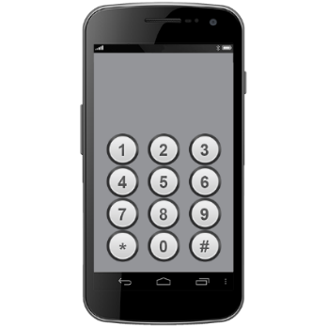
- Deaf / hard of hearing
- deafblind
- speech impaired / find it hard to talk.

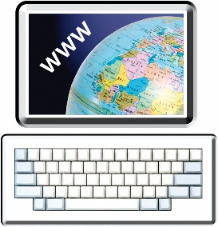
You can find out more about the New Zealand Relay service at:

www.nzrelay.co.nz

This information has been written by Wellington Water.

It has been translated into Easy Read by the Make it Easy Kia Māmā Mai service of People First New Zealand Ngā Tāngata Tuatahi.
The ideas in this document are not the ideas of People First New Zealand Ngā Tāngata Tuatahi.
Make it Easy uses images from:

- Changepeople.org

            - Photosymbols.com

- SGC Image Works

- Huriana Kopeke-Te Aho

- T. Wood.
All images used in this Easy Read document are subject to copyright rules and cannot be used without permission

